Brain Tumor Detection from MRI Images using Deep Learning
Mr. P.Venkateswarlu Reddy  Assistant Professor of CSE,  Mohan Babu University  (Erstwhile Sree Vidyanikethan Engineering College(Autonomous), Tirupati, Andhra Pradesh , India  Venkateswarlureddy.p@vidyanikethan.edu | Ms.L.Sumaiya Azeem  UG Scholar , Department of CSE,Sree Vidyanikethan Engineering College(Autonomous),Tirupati, Andhra Pradesh , India sumaiyaazeem01@gmail.com | Ms.M.Padma  UG Scholar , Department of CSE,  Sree Vidyanikethan Engineering College(Autonomous), Tirupati, Andhra Pradesh , India  Padmamala9121@vidyanikethan.edu
Ms.K.Divya Lakshmi  UG Scholar , Department of CSE,  Sree Vidyanikethan Engineering College(Autonomous), Tirupati, Andhra Pradesh , India  Divyalakshmiammu2000@gmail.com | Mr.L.Chakradhar  UG Scholar , Department of CSE,Sree Vidyanikethan Engineering College(Autonomous), Tirupati, Andhra Pradesh , India  Chakri.lingam@gmail.com

ABSTRACT
Brain tumors are twisted tissues in which cells repeat rapidly and indefinitely, being unable to control tumor growth. Deep learning uses Magnetic Resonance Imaging (MRI) to detect brain tumors as a method to easily identify brain tumors. A major challenge in identifying brain tumors is the isolation of abnormal cells. This paper aims to use Convolutional Neural Networks (CNN), ResNet50 and VGG16 to predict whether a person has a brain tumor from a dataset containing brain MRI images and compare their performance. These methods facilitate the easy detection of tumors for specialists. The accuracy results are stunning and gave a great insight into the behavioural promise of deep learning architectures on specific datasets. We examined brain MRI images of 3000 patients, of whom 1500 MRI images were tumorous and 1500 images were non-tumorous. This shows that the deep learning models can greatly contribute to the diagnosis of brain tumours, improving the accuracy and speed of diagnosis. Hence the usage of these models increases for the diagnosis of other complex diseases in the future.
Keywords: Magnetic Resonance Imaging (MRI), brain tumor, deep learning, Convolutional Neural Network (CNN), ResNet50, Vgg16.
- INTRODUCTION

A brain tumor is an abnormal growth of brain cells that lose control mechanisms in the brain. The tumors formed can put pressure in the brain and affect the physical health [1-2]. Early detection of these brain tumors is an important area of research in the medical imaging, helping to choose the most practical treatment to save the life of patients. Deep learning is a type artificial intelligence (AI) that mimics the abilities of the human brain to analyze data and generate patterns to make decisions. According to some studies, more than 28,000tumors are reported in India every year and more than 24,000 people die from this disease every year. MRI has proven to be the best diagnostic method for brain tumors. Unlike CT scan, MRI does not use potentially damaging X-ray radiation. MRI images are of high resolution and so detailed that they can detect even small things [2]. Nowadays, manually reviewing large numbers of MRI images and looking for brain tumors is very tedious and inaccurate work. Automated brain tumor detection methods are needed to reduce diagnostic time and avoid human error before any decision is made [3]. Moreover, there are many irregularities in the size and location of brain tumors, which makes the natural understanding of brain tumors problematic. In our proposed method, we use standard BRATS (MRI) dataset and conduct extensive experiments on this dataset and evaluate the efficacy of different deep learning models for brain tumor identification. Therefore, the use of imaging methods to study brain tumors is becoming increasingly important in radiology.
The following sections in this paper are organized as follows: Chapter 2 come up with a literature review while chapter 3 presents a methodology to process MRI images using CNN, ResNet50 and VGG16. Chapter 4 describes the results of the proposed method and compares the method with further deep learning models and finally the chapter 5 discusses.
2. Literature Review
N. Noreen et al [1] proposed a multi-level feature extraction and fusion algorithm for early tumor diagnosis. Pre-trained deep learning models, Inception-v3 and DenseNet validate this model. The proposed model gives a test accuracy of 99.34% and 99.51%, respectively and proves to be efficient. Abd-Ellah et al [2] reviewed in detail different diagnostic methods with brain MRI images. The authors also analyze various machine learning (ML) and deep learning (DL) algorithms in terms of limitations and performance measures. These techniques increase accuracy, speed and reduces noise over manual methods for the diagnosis. Hossain et al[3]Several machine and deep learning models have been proposed for brain tumor categorization and fragment, such as support vector machine (SVM), k-nearest neighbor (KNN), multilayer perceptron, Bayes theorem and Random Forest algorithms which refers to feature bagging. Among all these techniques, SVM accomplish the greatest accuracy 92.4%. And other deep learning model like CNN accomplish 92.7% accuracy in identifying brain tumor from MRI images. In the study [4] this article proposed a data fusion technique using two-dimensional and three-dimensional MRI images; with the help of deep learning models like DenseNet and a class three-dimensional CNN architecture for multimodal image categorization and fragment respectively. The above-mentioned models show great accuracy like 92% and 85% and also great efficiency. Majib et al [5], this article came up with a hybrid approach called VGG-SCnet (VGG Stacked Classifier Network). The pre-trained architecture of VGG16 was improved for making the model efficient and faster with the help of proposed layers for identifying the tumor from MRI images data set. The authors in [6] used a two-dimensional different transform based on Gabor filter and Wavelets for feature extraction from dataset of brain MRI images. This survey acquired an accuracy of 91.9% using above system configuration from neural network back propagation. The experiment results confirm the effectiveness of the feature selection method, to detect whether the tumor is present or not from dataset of brain MRI images.

3. Methodology:
Fig 1 shows a framework to illustrate the detection of tumor in the brain MRI images.
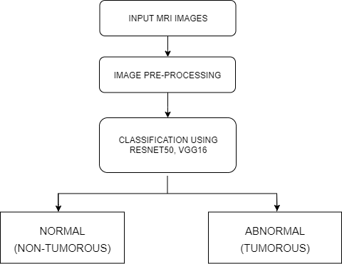
Fig 1 Framework for identification of tumor
Firstly, the methodology starts with taking brain MRI images of tumor patients as input. For research purposes these images have been obtained from Kaggle. This dataset contains MRI scans of patients with and without tumors.
Image pre-processing is a technique which aims to remove any unwanted distortion present in the images. To remove this unwanted noise smoothing is applied. Image enhancement and image smoothing are the two main steps of image pre-processing.
After pre-processing, different deep learning methods are used like CNN, ResNet50 and VGG16 which can detect the tumor accurately in a very less time. The accuracy results of these algorithms are stunning.
In the detection step, the brain MRI images are classified into two classes like normal(non-tumor) and abnormal(tumor) groups using effective algorithms such as CNN, ResNet50 and VGG16. The acquired results are compared to choose the best algorithm for the tumor detection.

3.1 Dataset used:
There are 3000 MR images in the dataset, of which 1500 are considered yes(tumor). Another 1500 scans said no (no tumor). Our partial selection depends on removing images that can bias the model evaluating. The image dataset used in this experiment is an open source dataset available on Kaggle. This dataset is a part of the Brats2020 Licensed Brain Tumor Reference dataset.
Convolutional Neural Networks
CNN is a well-established technique in medical imaging. CNNs are the most commonly used setup for MRI and other image processing applications. Data is usually entered as a 2D or 3D array of pixels, and the initial computation phase is limited to operations on adjacent pixels [3]. The brain MR image layers of the CNN Architecture are shown in figure 2. The network receives the input images in batches of 50 at a time. All images are resized to be 32 x 32 pixels and are all RGB. These layers are fully connected layers, three pooling layers, and three convolutional layers.
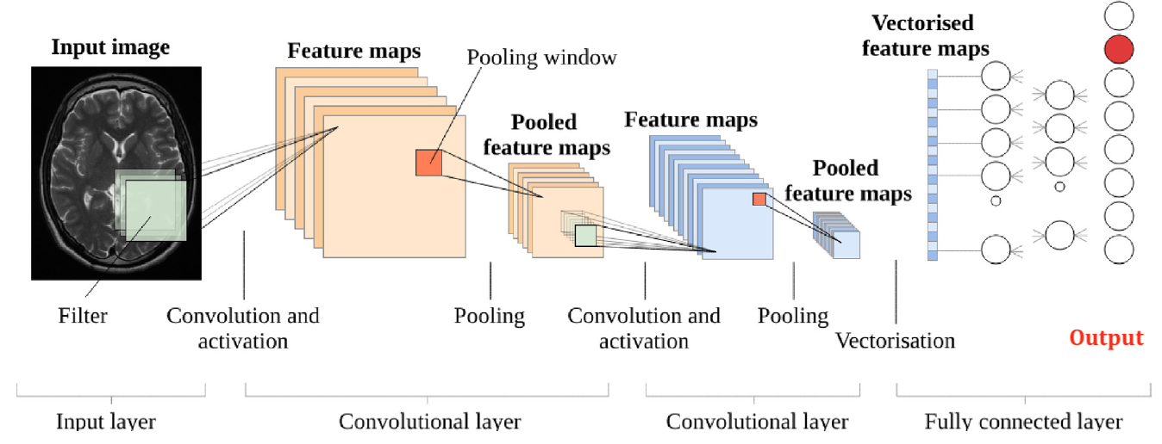
Fig 2 Layers in CNN Architecture
The network receives the input images in batches of 50 at a time. All images are resized to be 32 x 32 pixels and are all RGB. These layers are fully connected layers, three pooling layers, and three convolutional layers.
Advances in computer vision has been built and developed, in particular thanks to structured framework called CNN. A CNN is a DL process that takes various elements of an image and prioritizes them so that they can be distinguished from each other [3-4]. Individual features of a neural layer are called neurons, and the output of a neuron is defined by its surrounding pixels. Perceptrons are regions of pixel density that can influence neural responses. The computational efficiency of neurons increases with thenumber of convolution operations in the design. CNN's layer division has a hierarchical system.
ResNet
In this experimental work, the Resnet50 multi-layer deep CNN framework for the transfer learning process is introduced. This model is a pre-defined method on the ImageNet database to detect brain tumor on different pictures. This provides ImageNet with pre-trained weights as initial weights for the proposed deep neural network. The remaining layers in this architecture play an important role in transferring huge gradient values ​​to adjacent layers above. The brain MR image layers of the ResNet50 Architecture are shown in figure-3.

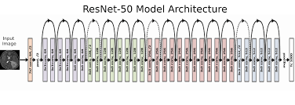
Fig 3 Layers in ResNet50 Architecture
ResNet directly connects the input of the kth layer to the (k+x)th layer with shorthand knowledge of each of thepairs of thirty-three filters. The reasoning behind the avoidance layers is to keep free from problematic leakage gradients by cycling initiations from the previous layers to adjacent layers whose weights have already been learned.
VGG16
VGG16 is a 16-layer CNN model. It is still judged as one of the best and the most influential methods available today. The architecture of the VGG16 model does not have a large large number of parameters, but instead focuses on ConvNet layers with a 3x3 core size [5-6]. It stands out for its simplicity compared to other complete products developed. The minimum expected input image size for the model is 224x224 pixels with three channels. Figure 3 shows a standard VGG 16 network architecture.
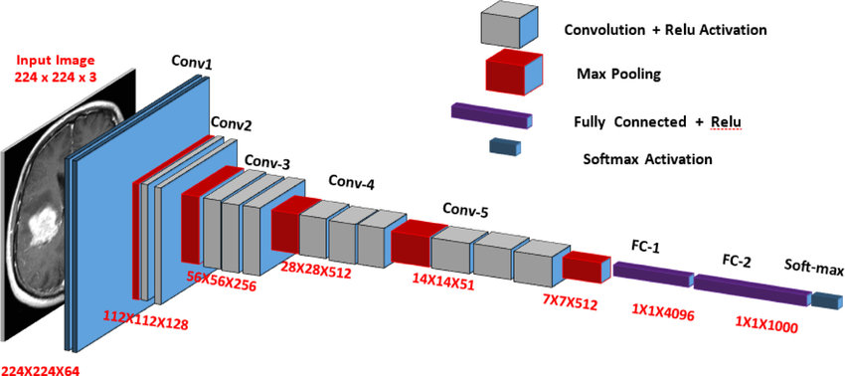
Fig 4 A Standard VGG Network Architecture
Neurons in a neural network work together with weights, biases and the associated training process. The switching weights of the neuron are adjusted according to the imprecision of the output. In put layers and activation functions add non-linearity to artificial neural input that enables learning and performing difficult tasks.
5. Results:
The optimal use of CNN, ResNet50 and VGG16 for brain tumor diagnosis was investigated.
CNN
Figure - 5 shows the brain MRI image having tumor and Figure - 6 shows the image with no tumor respectively using CNN. Figure - 7 represents the graphical model loss depicted during detection of brain tumor.
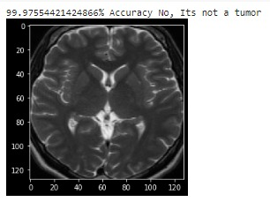
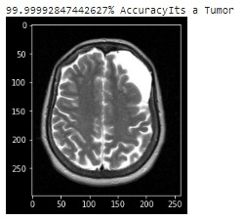
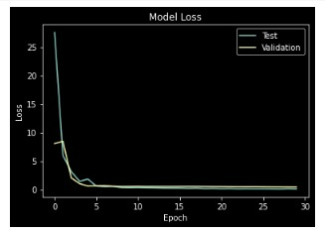
Fig 5 It’s a tumor Fig 6 It’s not a tumor

Fig 7 Graphical representation of model loss for tumor detection using CNN

ResNet
Figure - 8 shows the brain MRI image having tumor and Figure - 9 shows the image with no tumor respectively using CNN. Figure - 10 represents the graphical model loss depicted during detection of brain tumor.
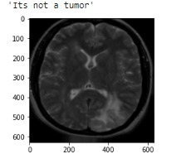
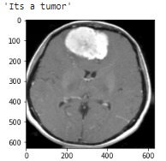
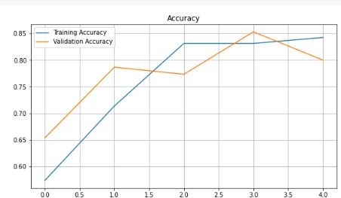
Fig 8 It’s a tumor Fig 9 It’s not a tumor
Fig 9 Graphical representation of model accuracy for tumor detection using Resnet50
VGG 16
Figure-11 shows the brain MRI image having tumor and Figure - 12 shows the MRI image with no tumor respectively using VGG16. Figure-13represents the graphical accuracy while predicting the tumor.
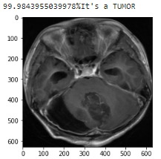
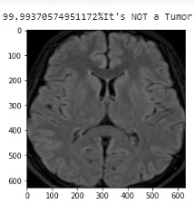

Fig 11 It’s a tumor Fig 12 It’s not a tumor
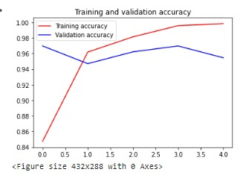
Fig 7 Graphical representation of model accuracy for tumor

Classifiers | Loss (%) | Val_Loss (%) | Accuracy (%)
CNN | 0.1072 | 0.4435 | 99.01
ResNet50 | 0.0310 | 0.5750 | 98.91
VGG16 | 0.0264 | 0.0446 | 99.87

Table-1 Comparison of performance metrics of CNN, ResNet and VGG16 Classifiers
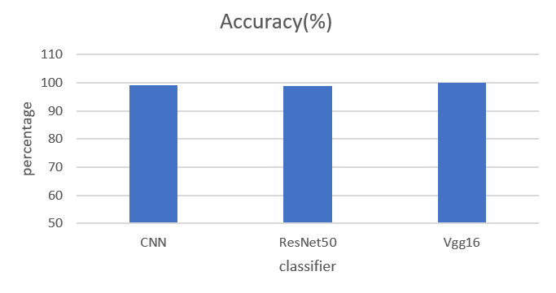Fig 14 Graphical Representation of accuracy for tumor detection using CNN, ResNet and VGG16 models.
The above figure-14 shows the evaluated results of accuracy of the three classifiers and it shows that vgg16 is better compared to remaining classifiers.
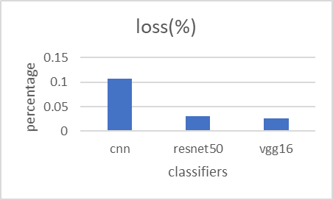
Fig 15 Graphical Representation of loss for tumor detection using CNN, ResNet and VGG16 models.
The above figure-15 shows the evaluated results of loss of the three classifiers and it shows that vgg16 is better compared to remaining classifiers.

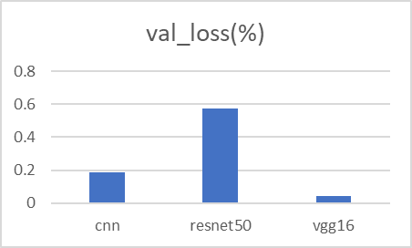Fig 16 Graphical Representation of validation loss for tumor detection using CNN, ResNet and VGG16 models.
The above figure-16 shows the evaluated results of validation loss of the three classifiers and it shows that vgg16 is better compared to remaining classifiers.
5. Conclusion:
The article discusses the implementation of deep learning algorithms to brain tumor recognition. In this survey, various deep learning methods such as CNN, ResNet50, VGG16 were evaluated and the proportional results were compared to select the outstanding CNN model for detecting the tumors from MRI images. The top performance model, VGG16, showed the highest accuracy of 99.9% among the models in this survey. The proposed techniques can also be extended to classify tumor types such as glioma, meningioma, pituitary tumor using MRI image datasets. This work finally concludes us that among all the three evaluated classifiers VGG-16 performs well in terms of accuracy, loss and validation loss.
REFERENCES:
- N. Noreen, S. Palaniappan, A. Qayyum, I. Ahmad, M. Imran and M. Shoaib, “A Deep Learning Model Based on Concatenation Approach for the Diagnosis of Brain Tumor,” in IEEE Access, vol.8, pp. 55135-55144, 2020, doi: 10.1109/ACCESS.2020.2978629. M. K.
- Abd-Ellah, A. I. Awad, A. A. M. Khalaf and H. F. A. Hamed, "A review on brain tumor diagnosis from MRI images: Practical implications key achievements and lessons learned", Magn. Reson. Imag., vol. 61, pp. 300-318, Sep. 2019.
- G. Kumar, P. Kumar and D. Kumar, "Brain tumor detection using convolutional neural network", Proc. IEEE Int. Conf. Mobile Network Wireless Communication (ICMNWC), pp. 1-6, Dec. 2021
- H. Yahyaoui, F. Ghazouani and I. R. Farah, "Deep learning guided by an ontology for medical images classification using a multimodal fusion", Proc. Int. Congr. Adv. Technol. Eng. (ICOTEN), pp. 1-6, Jul. 2021.
- M. S. Majib, M. M. Rahman, T. M. S. Sazzad, N. I. Khan and S. K. Dey, "VGG-SCNet: A VGG net-based deep learning framework for brain tumor detection on MRI images", IEEE Access, vol. 9, pp. 116942-116952, 2021
- S. Solanki, U. P. Singh, S. S. Chouhan and S. Jain, "Brain Tumor Detection and Classification Using Intelligence Techniques: An Overview," in IEEE Access, vol. 11, pp. 1287012886,2023, doi:10.1109/ACCESS.2023.3242666.
- W. Yu, H. Kang, G. Sun, S. Liang and J. Li, "Bio-Inspired Feature Selection in Brain Disease Detection via an Improved Sparrow Search Algorithm," in IEEE Transactions on Instrumentation and Measurement, vol. 72, pp. 1-15, 2023, Art no. 2500515, doi: 10.1109/TIM.2022.3228003
- S. Ahmad and P.K. Choudhury, “On the performance of Deep transfer Networks for Brain Tumor Detection Using MR Images,” in IEEE Access, vol. 10. Pp.59099-59114, 2022, doi: 10.1109/ACCESS.2022.3179376
- A. Anaya-Isaza and L. Mera-Jiménez, "Data Augmentation and Transfer Learning for Brain Tumor Detection in Magnetic Resonance Imaging," in IEEE Access, vol. 10, pp. 23217-23233, 2022, doi: 10.1109/ACCESS.2022.3154061
- A. S. Musallam, A. S. Sherif and M. K. Hussein, "A New Convolutional Neural Network Architecture for Automatic Detection of Brain Tumors in Magnetic Resonance Imaging Images," in IEEE Access, vol. 10, pp.27752782,2022doi:10.1109/ACCESS.2022.3140289
- A. Hossain et al., "A YOLOv3 Deep Neural Network Model to Detect Brain Tumor in Portable Electromagnetic Imaging System," in IEEE Access, vol. 9, pp. 82647-82660, 2021, doi: 10.1109/ACCESS.2021.3086624.
- W. Wang, F. Bu, Z. Lin and S. Zhai, "Learning Methods of Convolutional Neural Network Combined with Image Feature Extraction in Brain Tumor Detection," in IEEE Access, vol. 8, pp. 152659-152668, 2020, doi: 10.1109/ACCESS.2020.3016282
- M. Li., l. Kuang, S. Xu and Z. Sha, “Brain Tumor Detection Based on Multimodal Information Fusion and Convolutional Neural Network,” in IEEE Access, vol. 7, pp. 180134-180146,2019, doi:10.1109/ACCESS.2019.2958370.
- M. A. Ottom, H. A. Rahman and I. D. Dinov, "Znet: Deep Learning Approach for 2D MRI Brain Tumor Segmentation," in IEEE Journal of Translational Engineering in Health and Medicine, vol. 10, pp. 1-8, 2022, Art no. 1800508, doi: 10.1109/JTEHM.2022.3176737.
- L. Wang, J. Zhang, Y. Liu, J. Mi and J. Zhang, "Multimodal Medical Image Fusion Based on Gabor Representation Combination of Multi-CNN and Fuzzy Neural Network," in IEEE Access, vol. 9, pp. 67634-67647, 2021, doi: 10.1109/ACCESS.2021.3075953.

